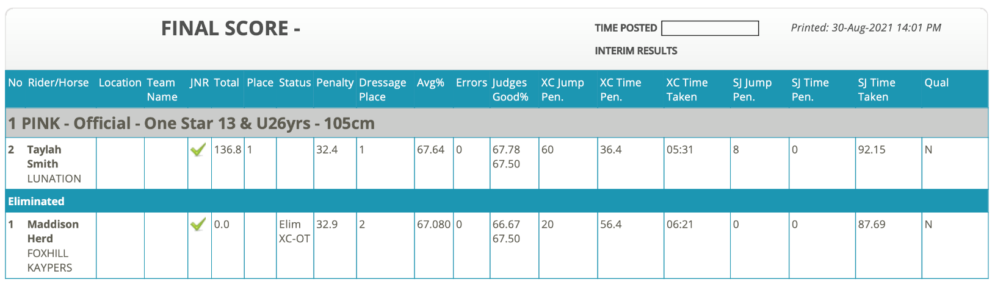

*Done by CS*



